

i@Connect-SWIFT User Guide

TABLE OF CONTENTS:-

Disclaimer 3
Copyright 3
About IDBI Intech Ltd 3
Overview 4
Access i@Connect from SIDBI_Core_Transaction 5
i-Connect Home Page 6
Home Page for Checker and Maker: 17
1.1 Creation
1.2 Modification
1.3 Verification
22

Disclaimer:-

This document contains confidential information about SIDBI_Core_Transaction its Intellectual property, methodologies, plans & internal processes and therefore is not meant for general circulation. It may be circulated internally, strictly on a need to know basis.

All rights reserved. These materials are confidential and proprietary to IDBI Intech Ltd. No part of these materials should be reproduced, published in any form by any means, electronic or mechanical including photocopy or any information storage or retrieval system nor should the materials be disclosed to third parties without the express written authorization of IDBI Intech Ltd.

Copyright:-

Copyright © 2009 IDBI Intech Ltd. All rights reserved. The IDBI Intech Ltd. logo and all other IDBI Intech Ltd product names and slogans are trademarks or registered. Other product names registered trademarks of their respective companies.

About IDBI Intech Ltd :-

IDBI Intech Ltd. is a Mumbai based e-business and IT services company that has better way to run IT projects. Company uses a staged development approach to delivering e-business initiatives and IT projects. An approach that not saves times and money, it produces better results.

Our approach breaks a problem down to its essence with a clear focus on delivering the most important Customer and business requirements first. And it allows the delivery of commercial application in a very short time frame while being underpinned by strict project governance and change management principles.

Overview:-
SWIFT application links Worldwide Financial Institutions/ Banks to transmit various
Transaction messages securely between the participating banks. The i@Connect application is a middleware that connects Core Banking Solution and SWIFT Alliance gateway for Straight through Processing (STP) of Outgoing Trade Finance Messages and to display branch wise incoming trade messages.

Salient features of I@Connect are:-

- Auto Generation of Messages from SIDBI_Core_Transaction.
- i@Connect after posting SIDBI_Core_Transaction.
- Avoids duplication of data entry i.e SWIFT Alliance.
- Single Sign On (SSO). Users should be able to log into i@Connect from
- CBS (Finacle) login.
- Get report of Incoming/Outgoing messages from SIDBI_Core_Transaction login.
- Users to be registered in i@Connect for generation of message through i– Connect Application’s Create Message Module .
Validations: - To avoid duplicate transmission
To confirm SIDBI_Core_Transaction is posted before initiation of message generation.

- To start with MT103,MT700,MT701,MT707,ETC

i-Connect Home Page:-

i-Connect home page menu options differs depending on the user rights. There are 3 levels of users’ namely Administrator and Checker and Maker.

i-Connect Login Page:-

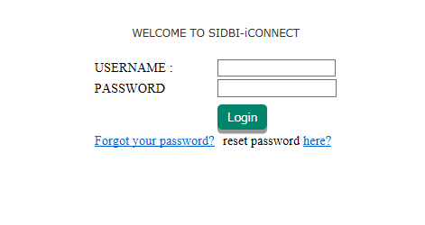

Home Page for Checker and Maker:-

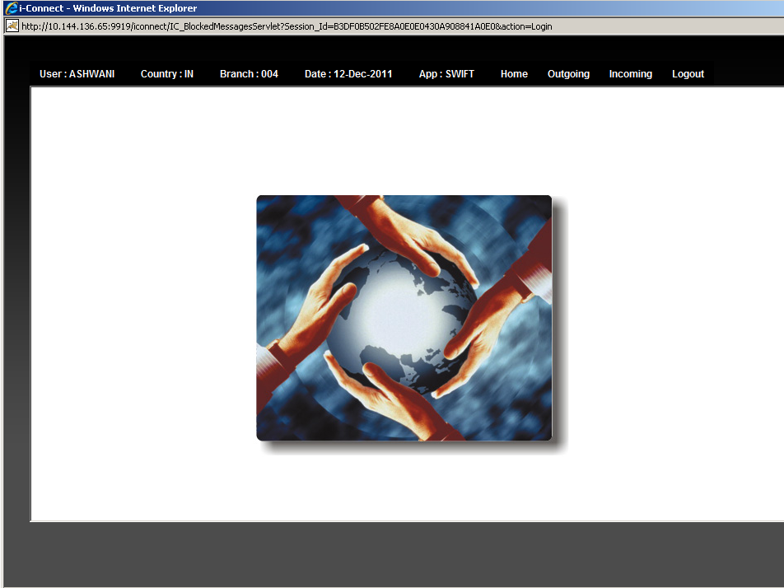

Checker can access:-

- All Outgoing Menu options
- All Incoming Menu option
- All messages of the branch logged in.

Maker can access:-
- Outgoing – Creation, Modification–& Reports
- Incoming – Modification & report

- Menu Option-OUTGOING:-
1.1 Create Messages
1.2 Modification
1.3 Verification
1.4 Report
1.5 Failed Messages
1.6 Template
Create Template
Modify Template

1.1 Creation Of Messages:-

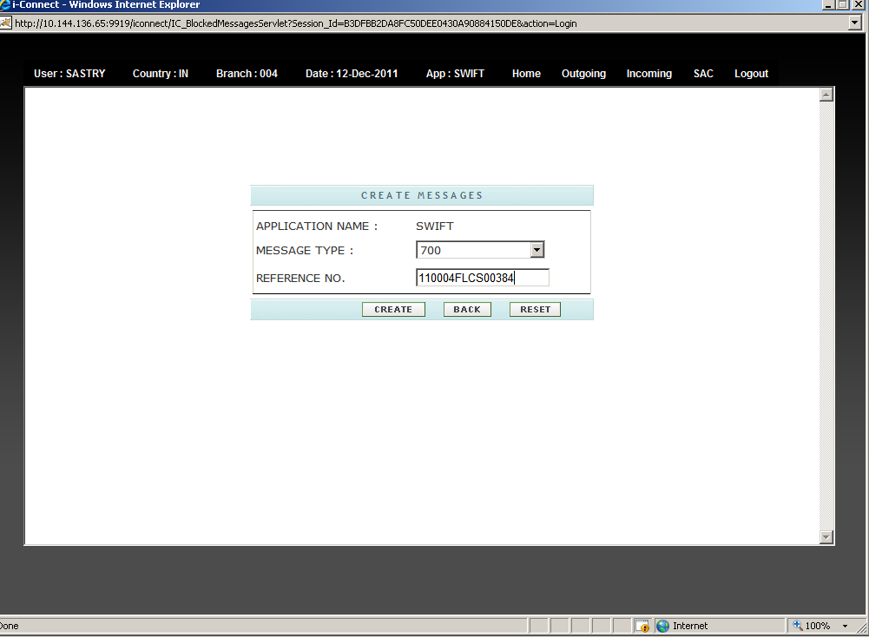

User can create message through this menu.

CREATE: Click this button to create a new message.
BACK: Click this button to go back to the home page.
RESET: Click this button to clear the fields / Refresh.

Notes:-
Create Message is used for creation of free format MT,s like 199,299,499,799,999,792 Other MT,s like 700,103,202,760 are Automatically created on Authorization of those MT,s In .

1.2 Modification:-

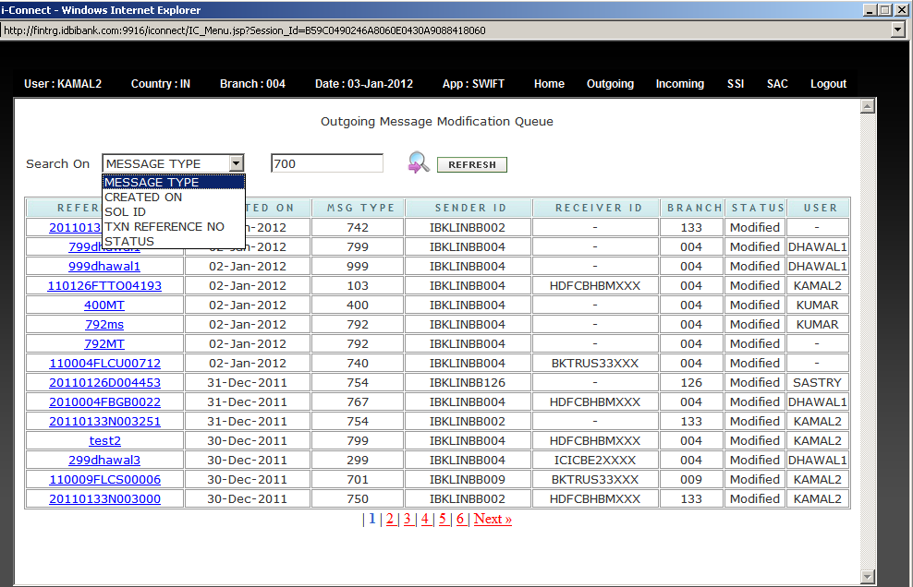

Modification queue lists all the messages that are created by user using the menu option “Create message”; which can be processed further.

Search On:- This drop down combo box is used for searching a message record based on
“Message Type”, “Create On” , “SOL ID”,”TXN REFERENCE NO” and “STATUS” .

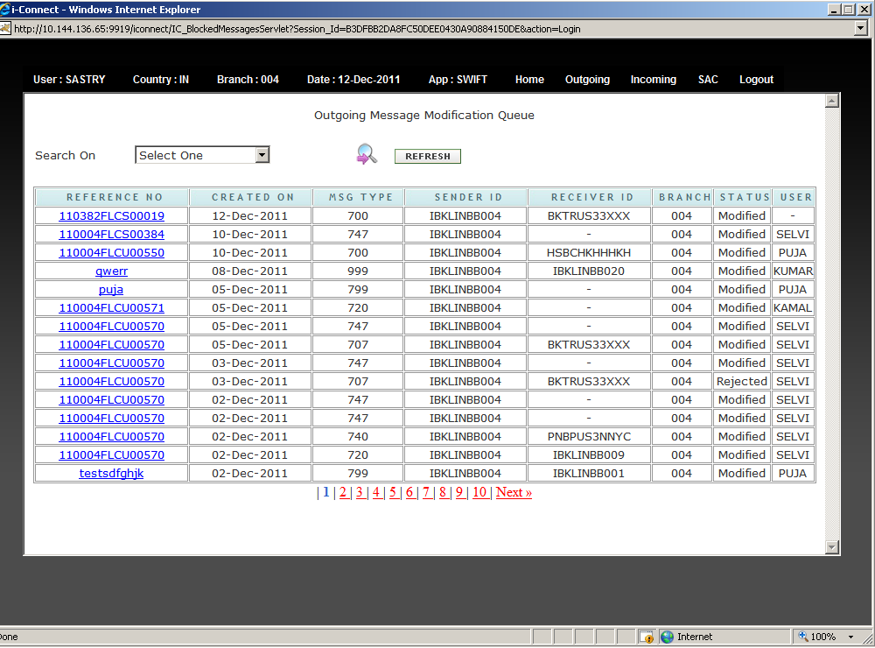

Click on any of the Reference No. to view the details of the message and modify it.
NOTES: Once the reference No is clicked the name of user is updated in the USER id block
Now only that user will modify and update the details of MT’s Another user Can’t.

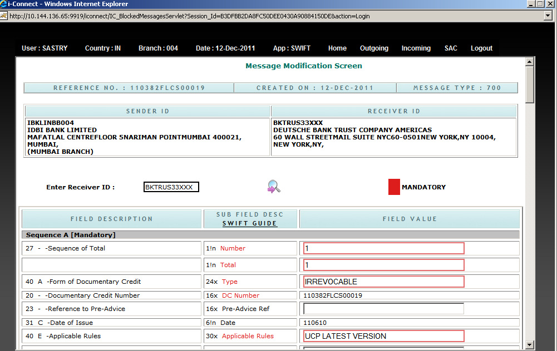
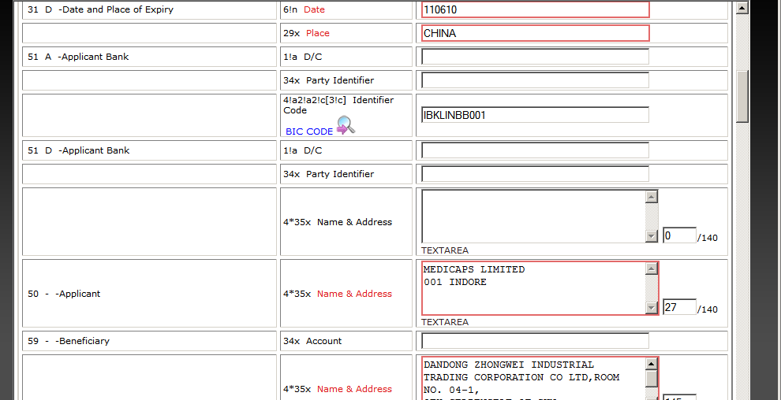
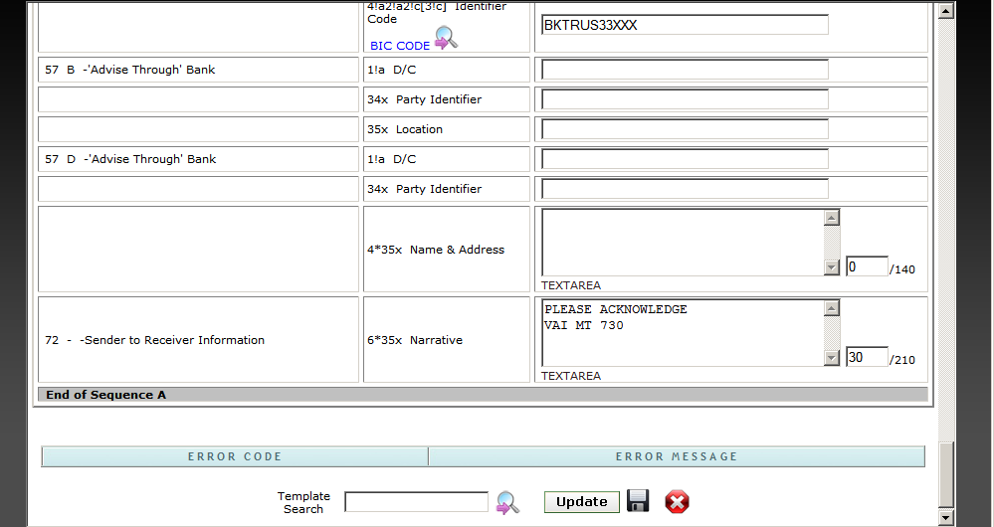

Select Template:- Enables user to select any created template (templates are created using menu
option Outgoing -> Create Template). If user selects any created template from the combo box, a
new button appears on the screen. User can click on “ApplyTemplate”
button to add the template to the current message.

:- Click update button to update the record and move it to verification. You will get a
message “DATA UPDATED FOR FURTHER PROCESSING.....” once you click on the update
button.

- :- Save Button - If user modifies any value and click the save Button, those field values get saved.

- :-Exit Button-To exist from this page and go back to outgoing message queue.

All The mandatory fields are Mark in Red color and values for Every mandatory fields are fetched from finacle Fields like Amount ,Currency, Date and place of Expiry are made as Non_Modifiable .

1.3 Verification:-
Users under checker category are allowed to verify messages. If maker (the user who
modified the message) accesses Verification menu, then the system displays the following
Message.

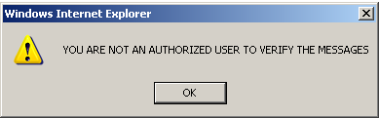

Verification screen for a Checker:-

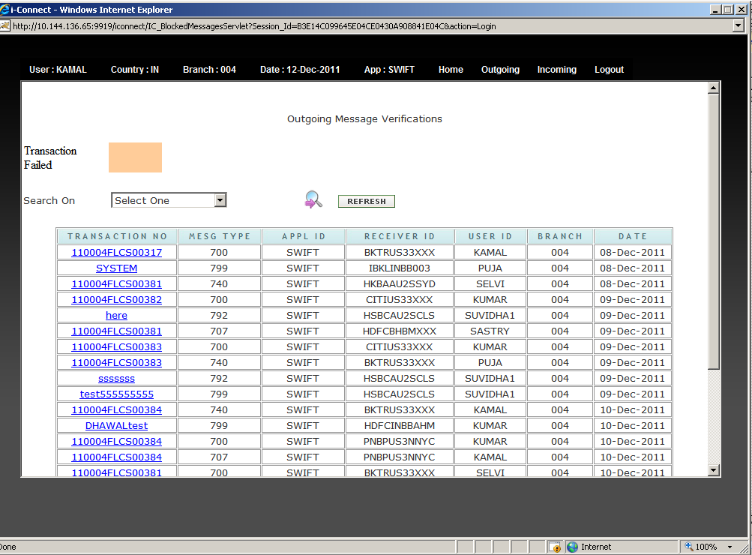

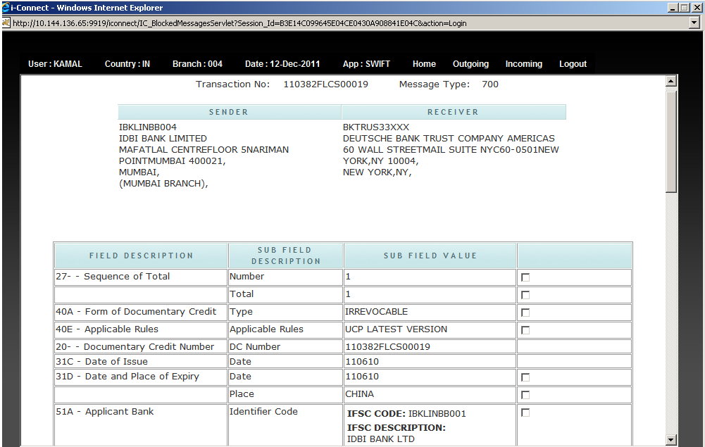
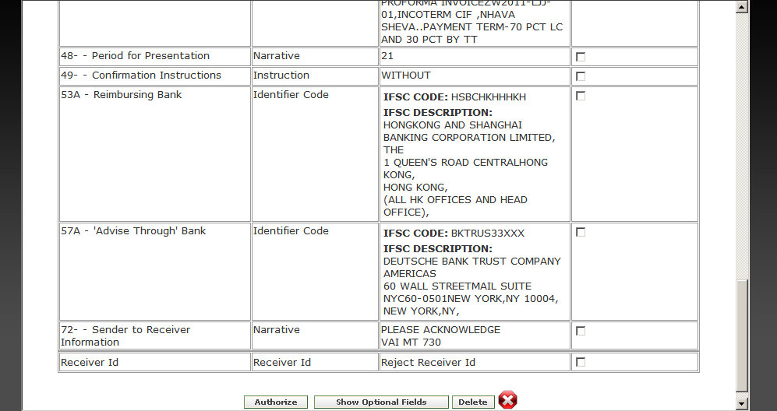

Checker has the following options:-

- Authorize:- Click this button to authorize a message and transmit to receiver’s bank

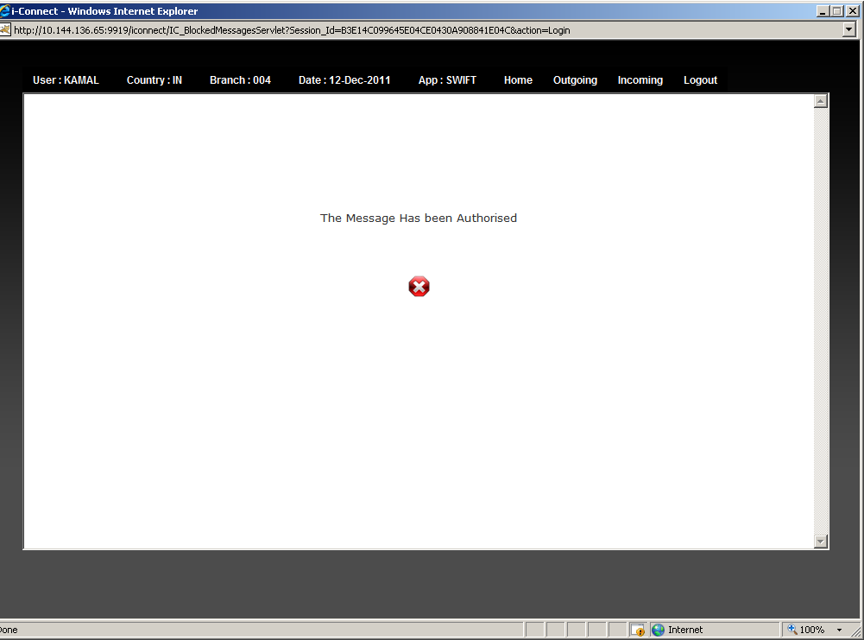

Note:-Message will be transmitted to respective Swift Alliance server and as per
bank’s Policy.

- Reject:-To Reject the message record. Supervisor can identify a field which needs
modification by clicking the combo box besides the field and then select reject button.
Supervisor is not allowed to modify any field. Rejected item will appear in
Modification Queue. Maker will be allowed to modify only that identified field and
submit again for verification. When the rejected item is resent to supervisor and if it is
not touched, it will be highlighted to supervisor with red font highlighting in the
combo box.

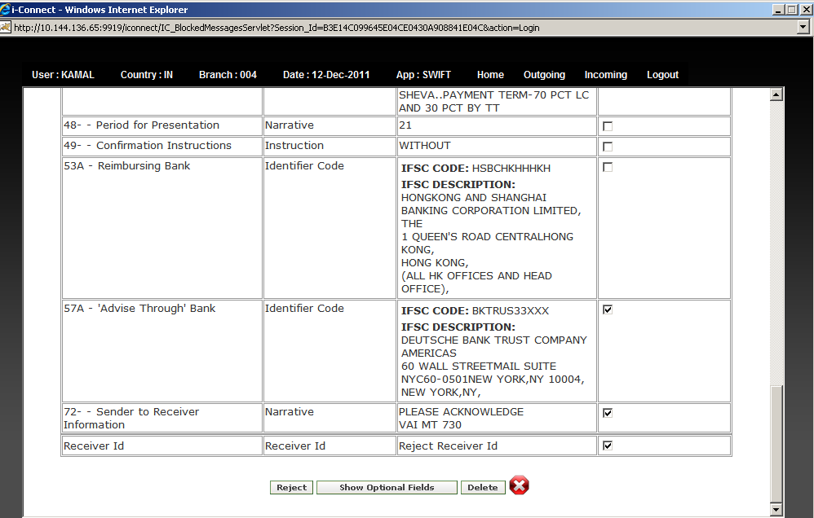

3. Delete:-To Delete the message record.

1.4 Modifying Rejected MT:-

After Rejection the MT will go to the same Maker who has created the MT Another users are not allowed to modify the detail. And the fields which are rejected are enabled and shown in blue color while the fields which are not rejected are disabled and shown in yellow color.

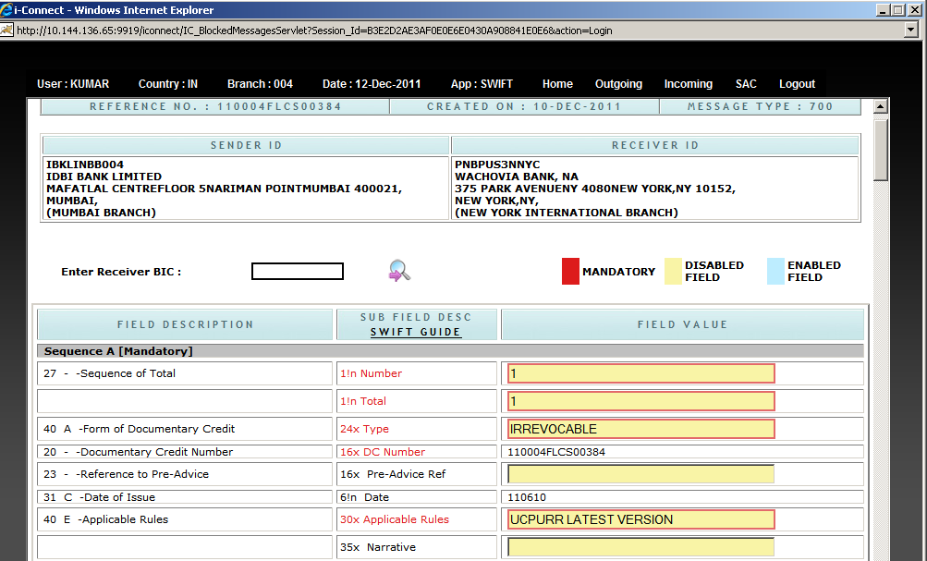
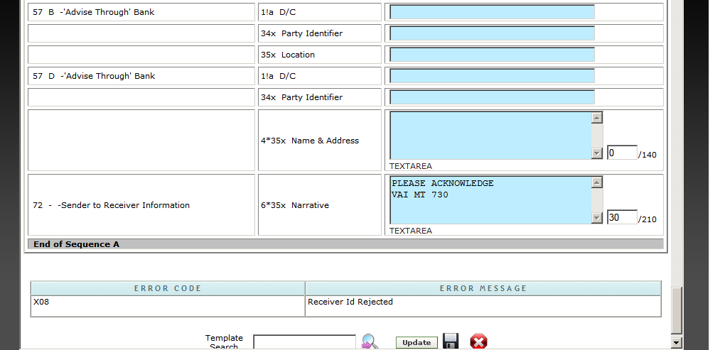

1.5 Reports:-

User can search for message records based on From Date and To Date, TxnReferenceNo,
Message Type, Sender ID, Receiver ID, Value, Currency and Message Status.

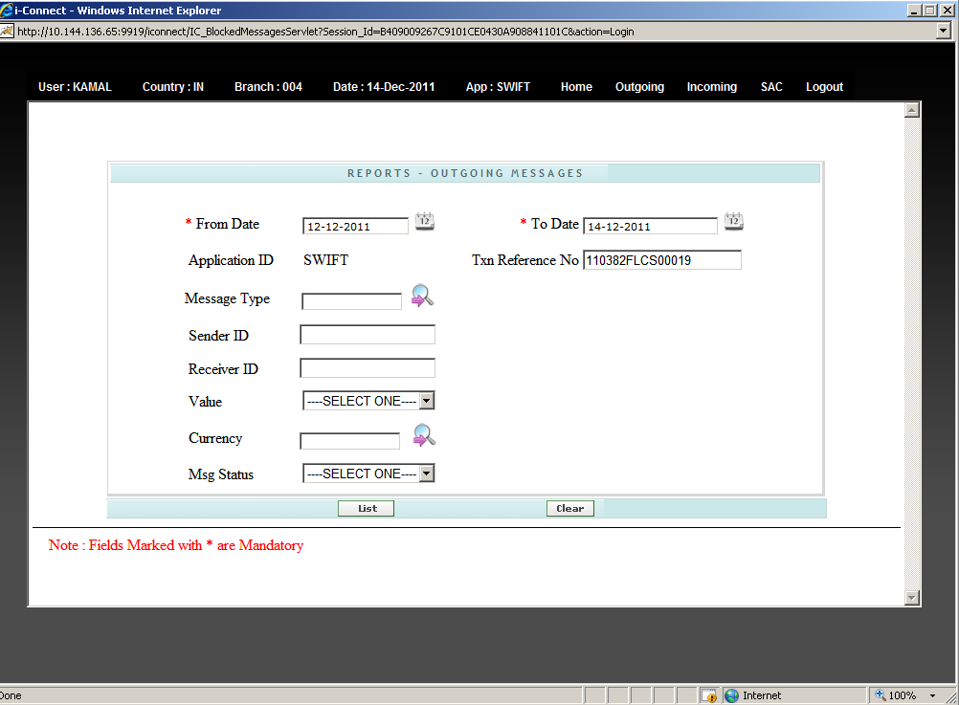

- Select From Date and To Date from calendar And Enter Txn Reference No .
- Once user clicks The List button The detail Report Got Opened.

Click on any of the Transaction ID to view the message in details.

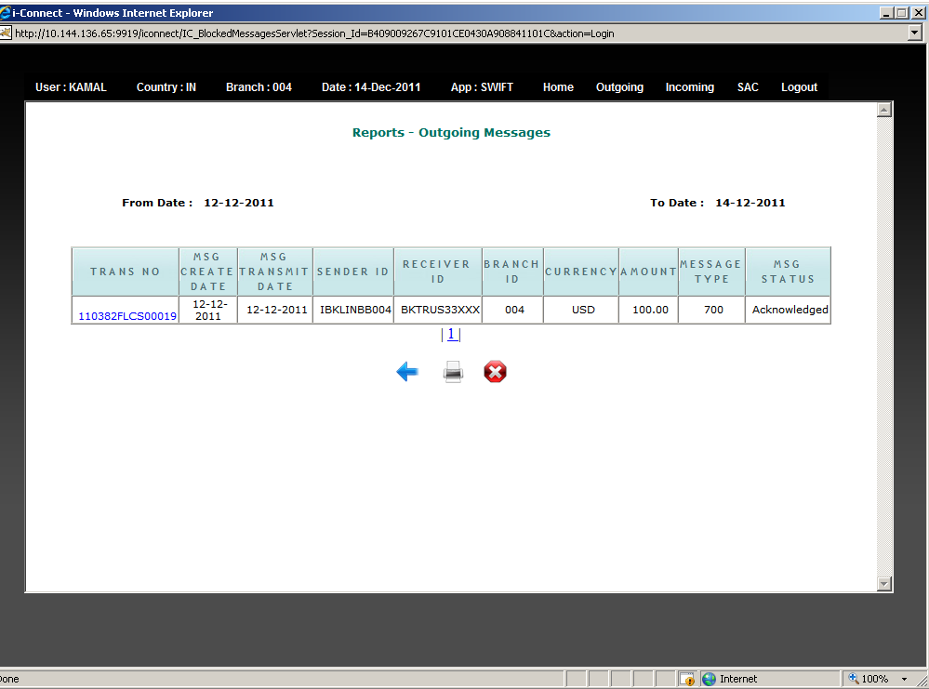

- There are three ways you can view a message from the report

- Message Details: - This shows the structured text format of message in detail.
(i@connect) transmits the message in this format to SWIFT).

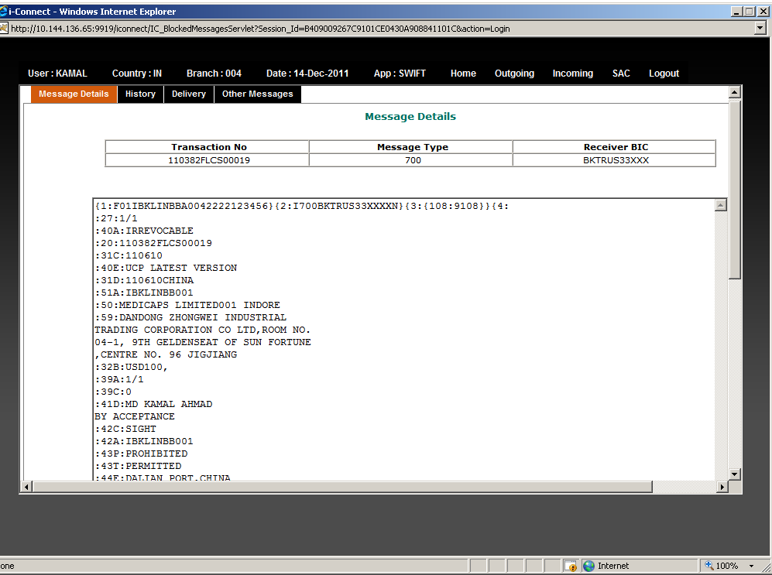

- History: - This shows details of the modification done to the current message by maker It will Show the name of the Maker who has done the changes and the specific values which has been changed.

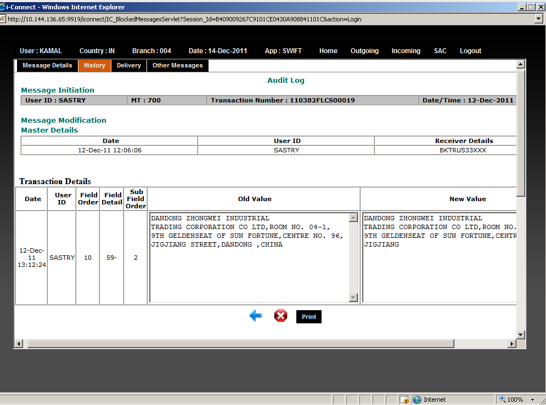

- Delivery: - This shows details message which system sends to the receiver bank In this option user has provision to Send Mail To Users and also print the MT.

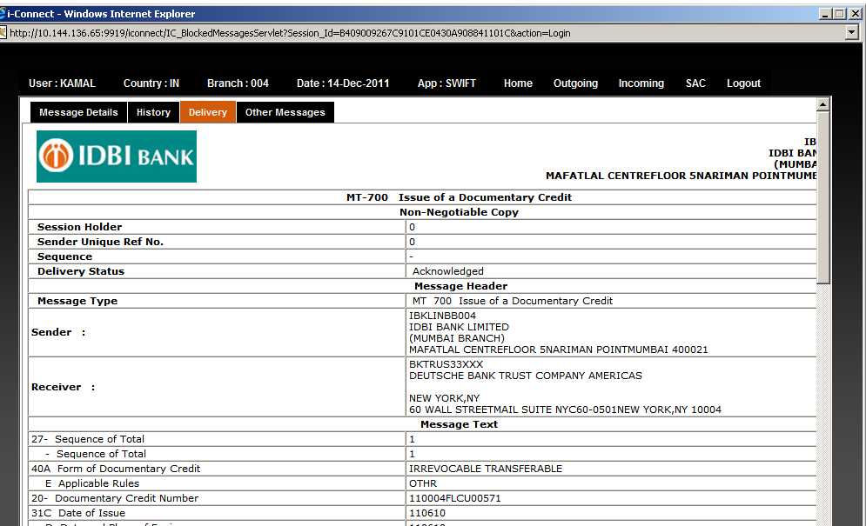
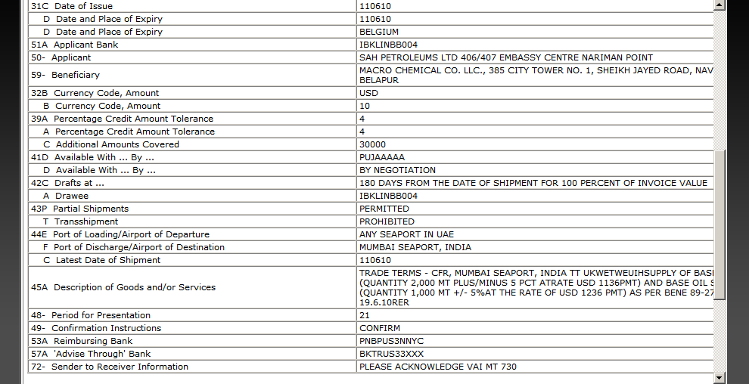
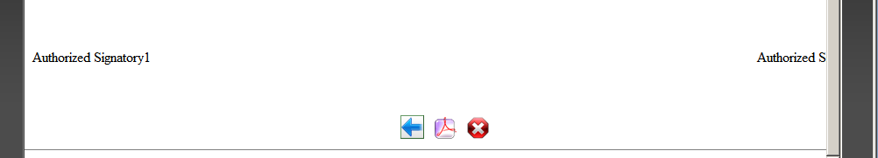

:- Click this button to view the message in PDF format.

:- Click this button to go back to Back.

:- To exist from this page and go back to Previous page.

After clicked on PDF Button User will get the following screen through which User can send mail with the attached PDF format of the document.

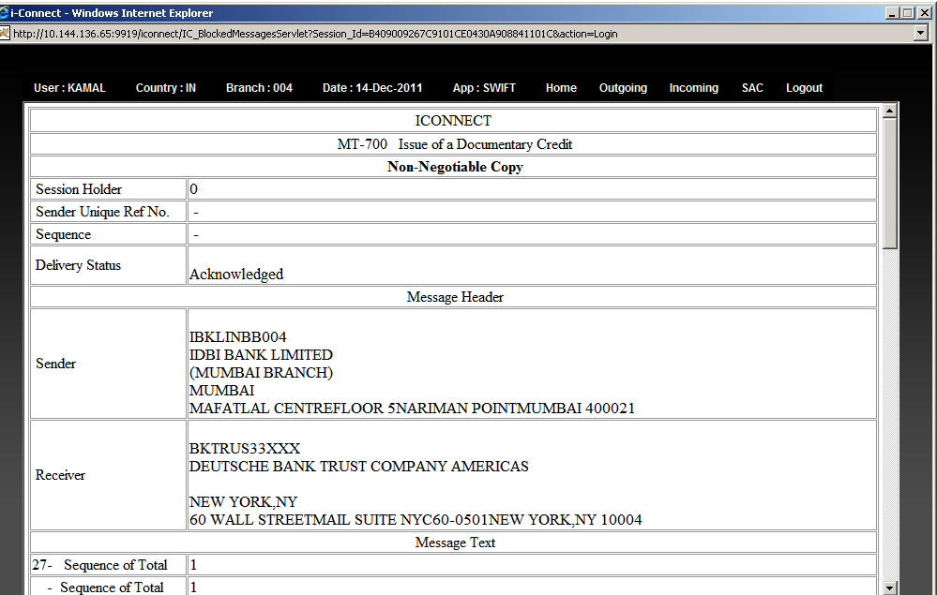
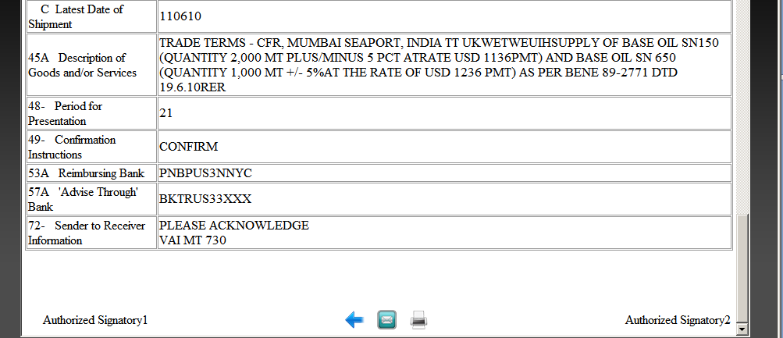

:-Click this button send the message by email.

:-Click this button to print MT.
By Clicking on Print Button User will get the following screen to Print the MT.

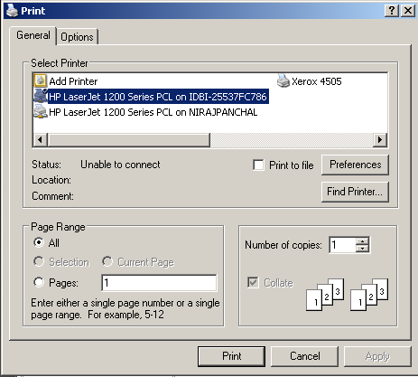

By Clicking on Email Button User will get the following screen to send the e-mail to the client or any other concern person.

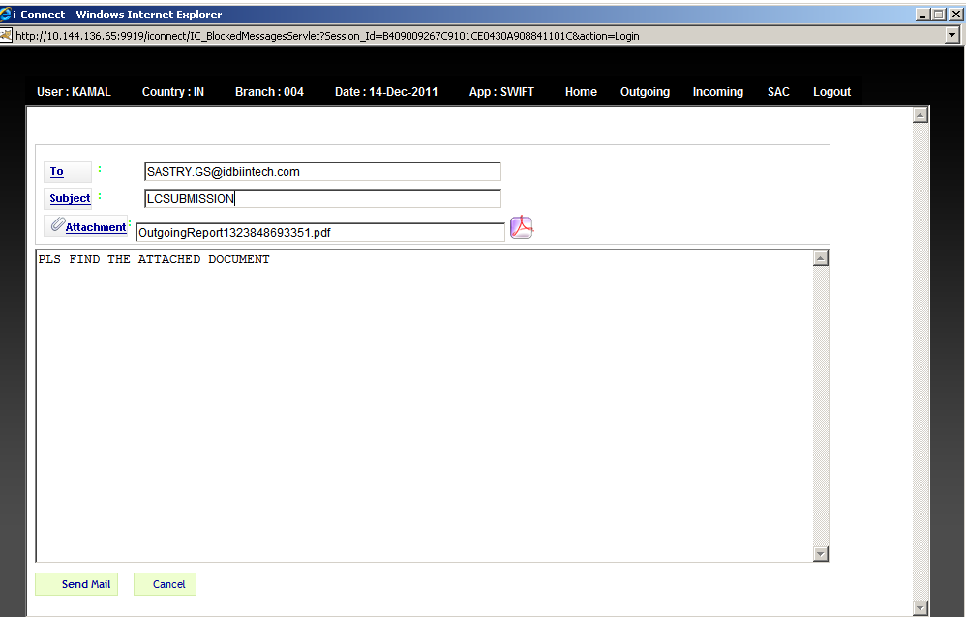

Click Send Mail button to send the mail.
Click Cancel button to go back to the Home page.

Email Automation:- While Transmitting a MT and receiving Ack - Nack copy for that MT an Email is sent automatic to client.

1.6 Failed Messages:-

Failed Messages in outgoing process are created during EODBOD process. During this process, cleaning of all the temporary tables and keeping a backup of the messages from
the temporary tables aredone. These records can be viewed through Failed Messages menu and screen. These failed messages can be either released or deleted by users with maker, checker and corporate rights.

1.7 Create Template:-
User can create templates based on message types. This template can be used at the time of
modification of a message to ease the modification process of a Documentary credit.
Template name should be unique for an application id.

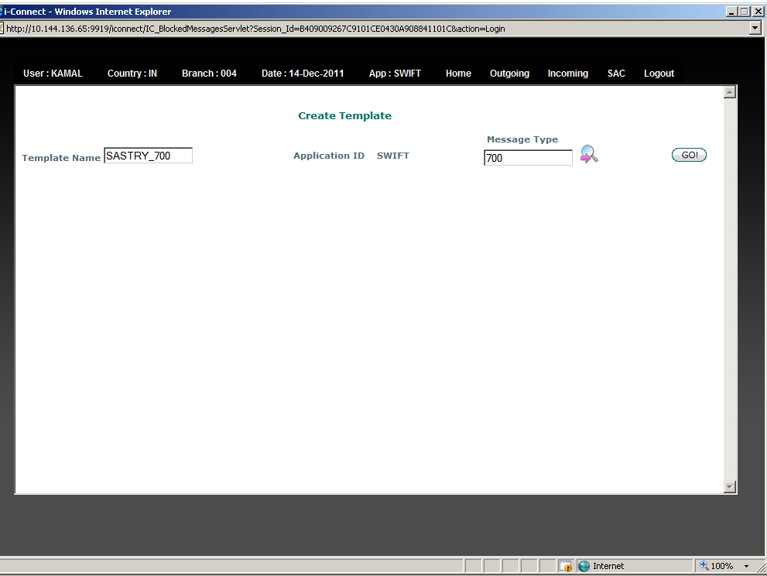

While clicking on Go button the Modification page for template is displayed as following

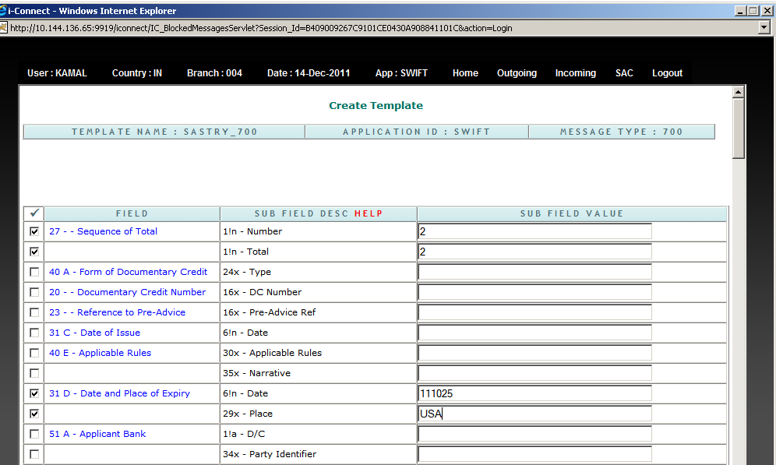
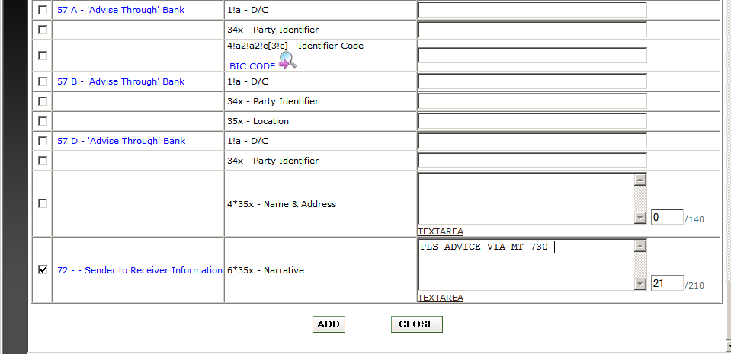

After completion of Adding Details in Template, user has to click on Add button to save the
template, for future reference while Modifying Message in Modification Module.

1.8 Verify Template:-To verify the Template created by other user.

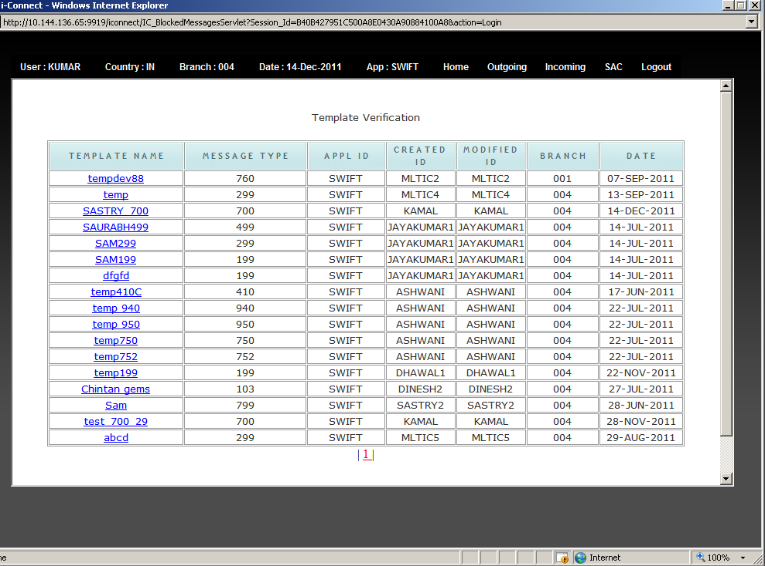

While clicking on any ref no the verification page got opened as mentioned below.

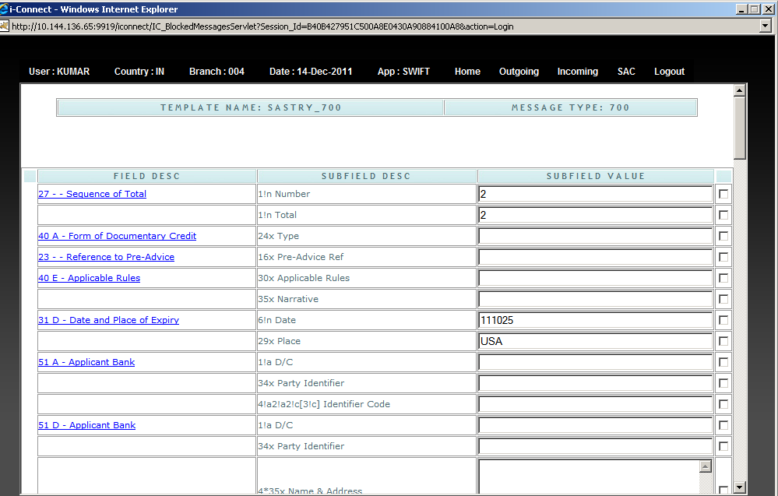
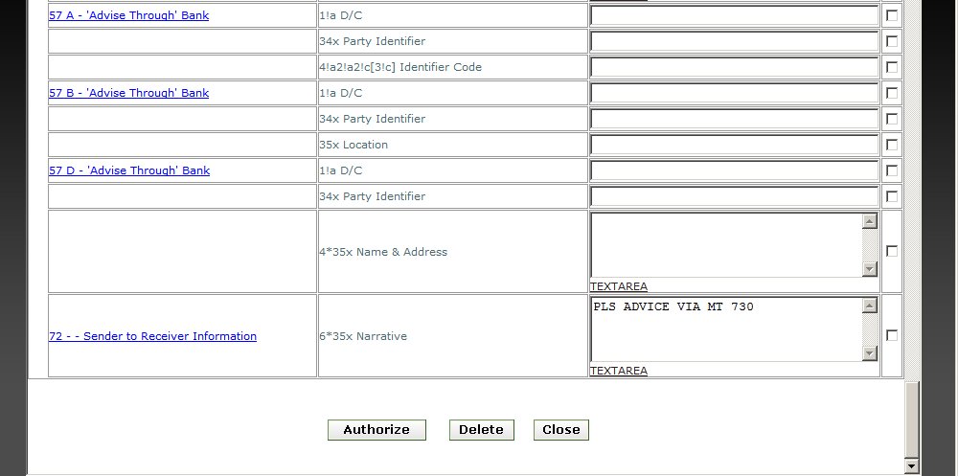

Authorize:- Click this button to authorize the template .

Delete:- To Delete the template record completely from the queues.

1.9 Modify Template:-

User can modify the existing template or enter additional details as per the requirement.

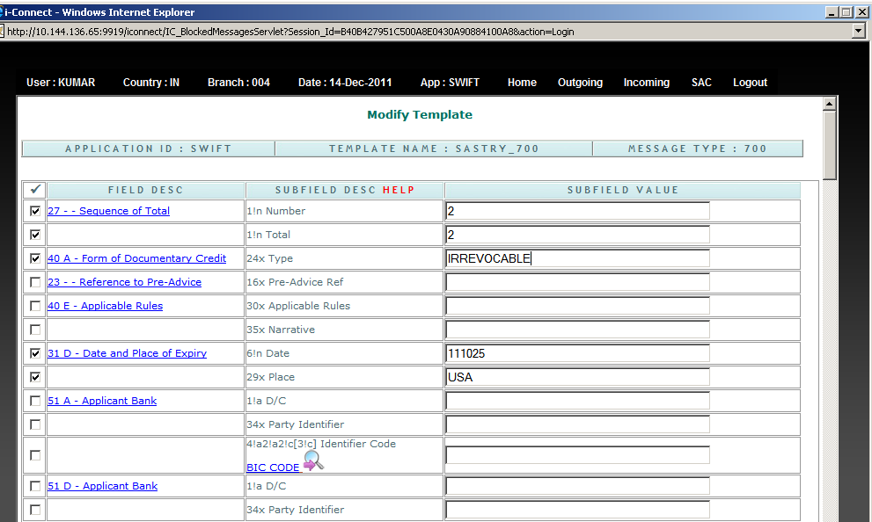
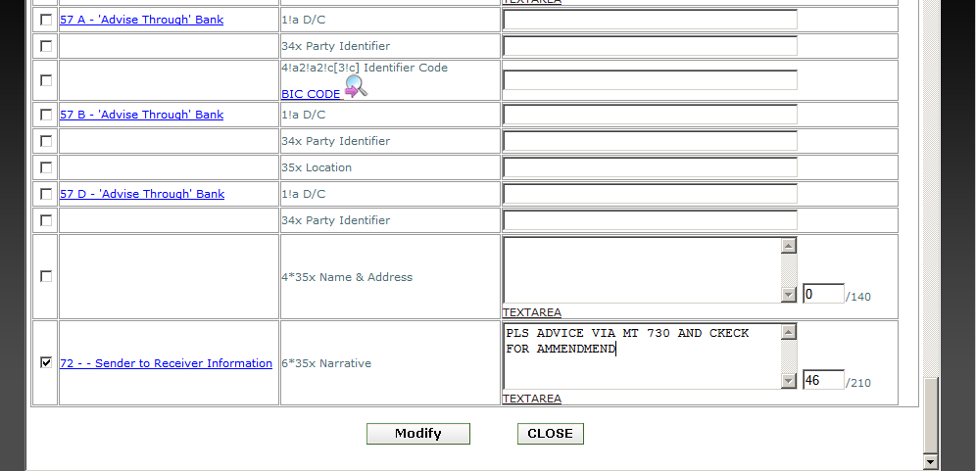

Modify:- To Modify The Values Of template

2.Menu Option:-Incoming

2.1 Modification
2.2 Verification
2.3CommonMessage
2.4 Reports
2.5 Failed Messages

2.1 Modification
To see the details of a message from the displayed list, User have to click on the sender ref no link of a particular message.

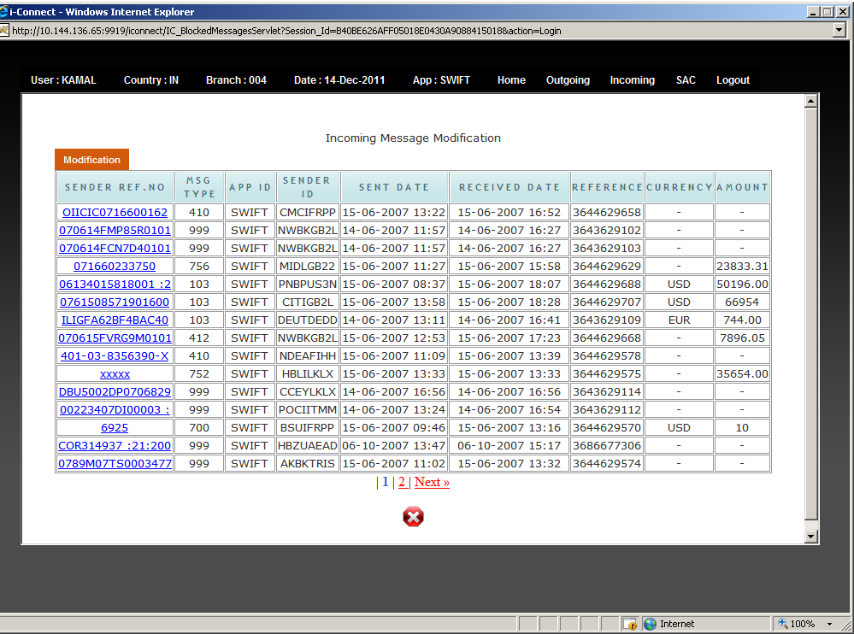

After clicked on the link of a message User will get the following screen with all the details about the message sent by the other bank.

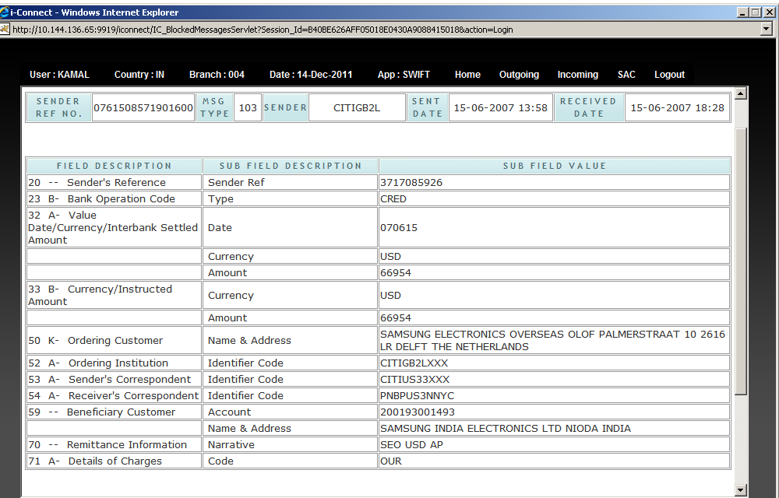
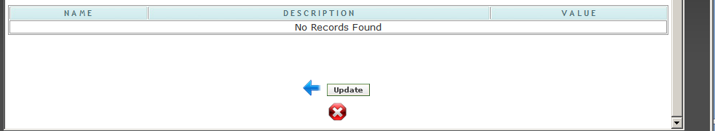

UPDATE:- On clicking On Update button the MT Will go to Verification queue.

  - Verification:-

This option is available only for the Checker Group User. Once the checker clicks on
Verification menu, he will get the list of message which is needs to be verified.
To see the details of the message checker needs to be click on Trans No link of a
Particular message.

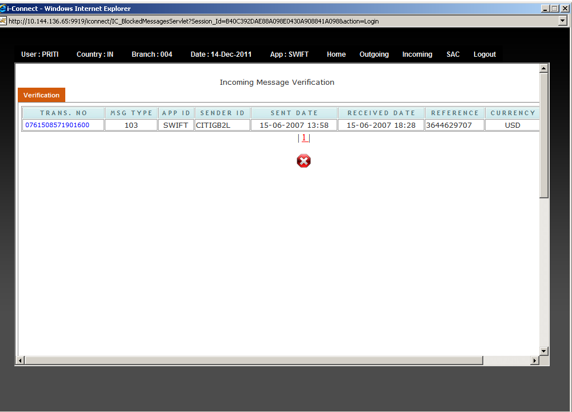

Once user click on the link of a Trans No, he will get the following screen with all the details of a selected message.

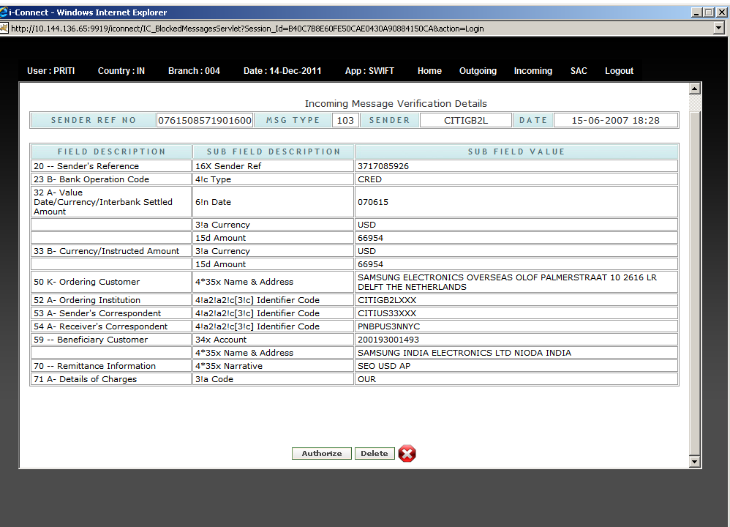

  - Common Message :-This option is available to CU User Only. The Incoming MT,s which come to XXX sol CU User can Route Those MT,s to any specified Sol.

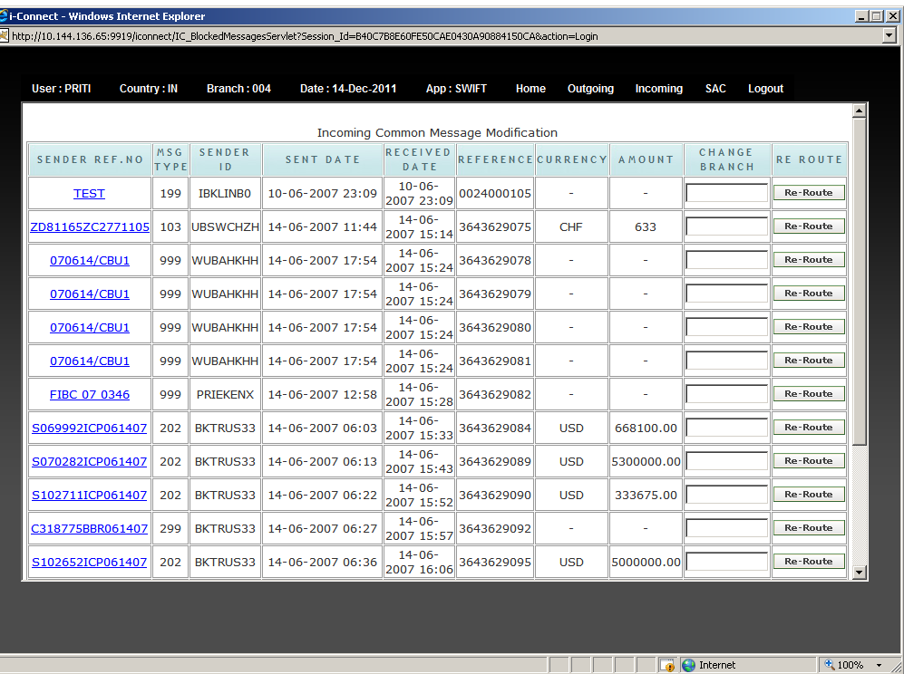

:-On Clicking on Re-Route button a window with sol id will be opened as
Below .User can select any sol where he want to Re-Route MT.

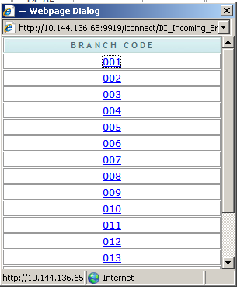

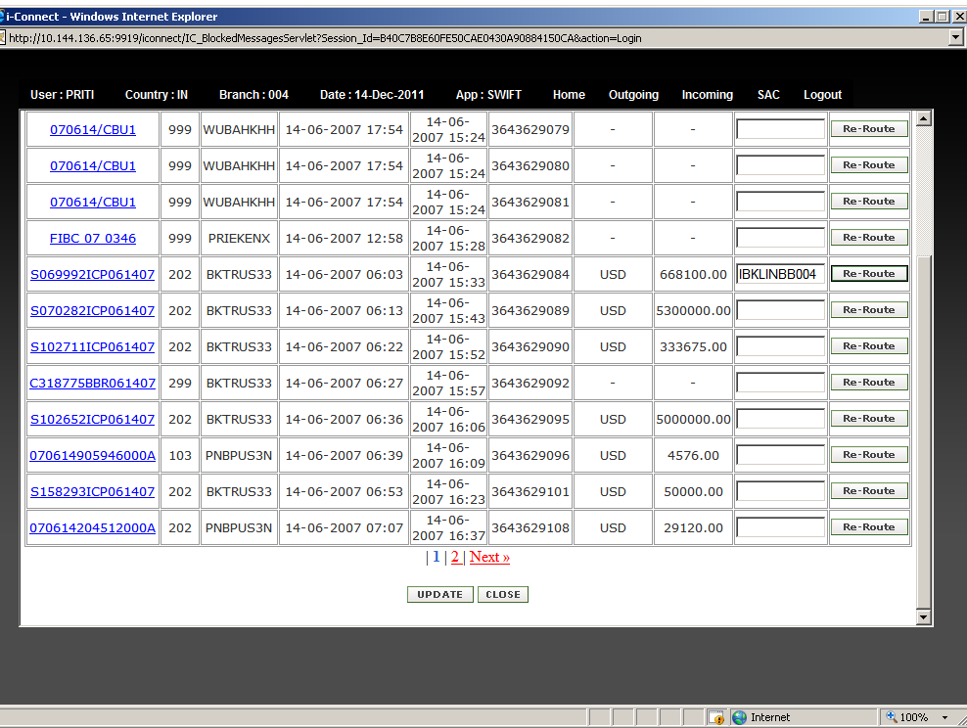

Update:-On Clicking on update button the above MT will re route to 004 SOL

  - Reports:-

This menu option is used to see incoming message report .

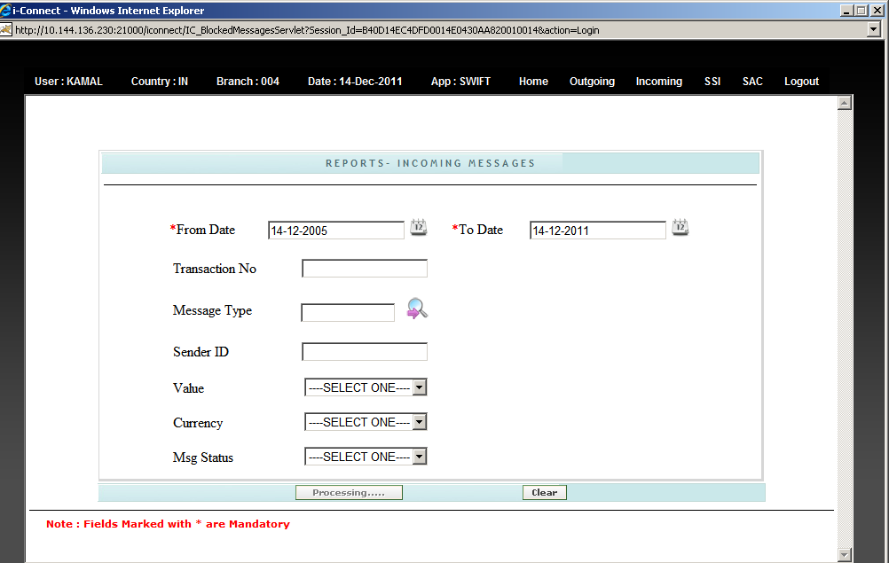

Once User click on List button of Report page, User will get the following screen which is
having those messages which are satisfying your search criteria.
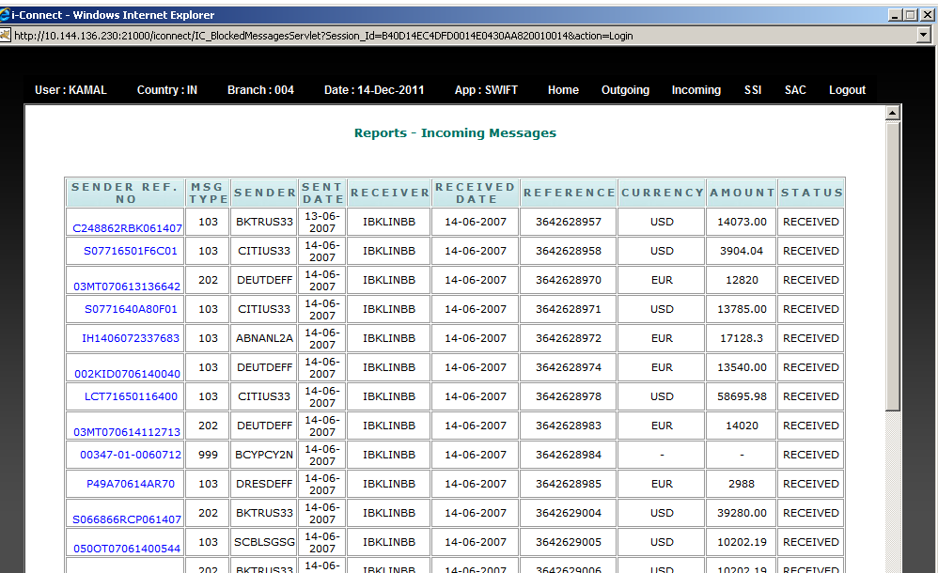

- On Clicking on any Reference no The datails of any incoming MT got opened.

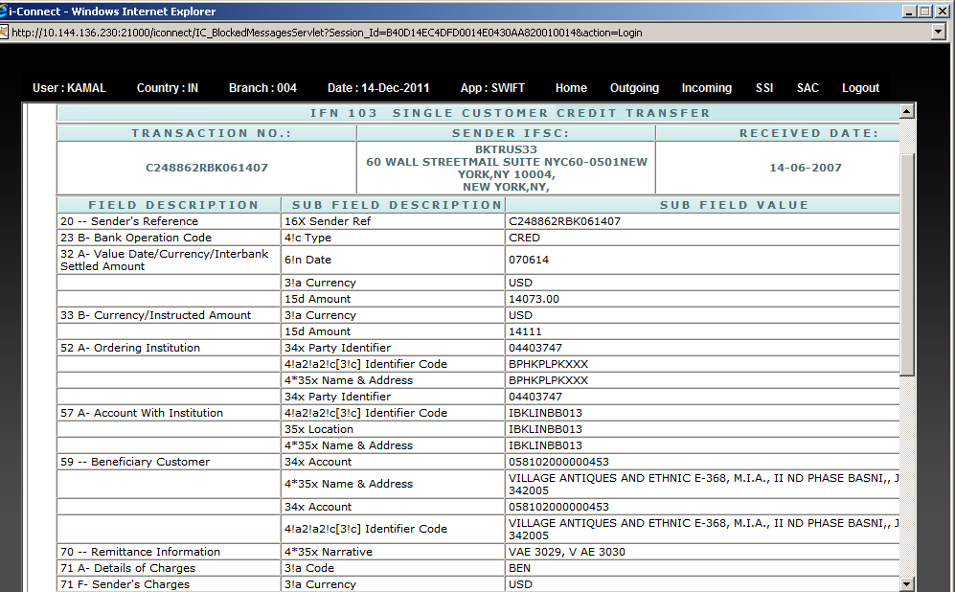
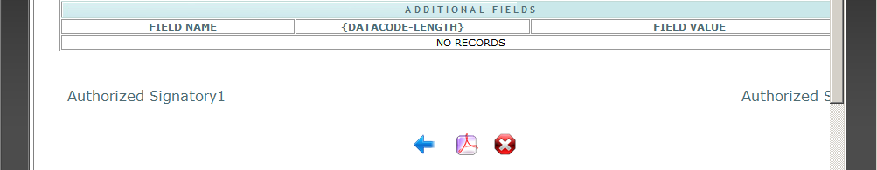

- On clicking on PDF Option the mail and print option will Come.
